Exploratory Analysis of Rainfall Data

in India for Agriculture

Final Report

Team id: LTVIP2026TMIDS91693
Team Leader: Priyatham Aremanda
Team member: Kancharana Hariprasad
Team member: Shaik Naseera
Team member: Chintada Yaswanth

- INTRODUCTION

Project Overview
The Exploratory Analysis of Rainfall Data in India for Agriculture project focuses on analysing historical rainfall data to extract meaningful insights that support agricultural decision-making. Using data visualization, statistical methods, and machine learning techniques, the project examines rainfall trends, variability, and regional patterns. The analysis aims to assist farmers, agricultural experts, and policymakers in understanding rainfall behaviour and applying insights to crop planning, irrigation management, and risk mitigation.

Purpose
The purpose of this project is to transform raw rainfall data into actionable insights that can enhance agricultural productivity and planning. By identifying patterns and predicting trends, the project supports efficient water usage, informed crop selection, and better preparedness for adverse climatic conditions.

IDEATION PHASE

Problem Statement
Unpredictable rainfall patterns across India create challenges for agriculture, including crop loss, inefficient irrigation, and poor risk planning. There is a need for analytical tools that interpret rainfall data and provide useful insights to guide agricultural decisions.

Empathy Map Canvas
    - Think & Feel: Concerned about crop success and water availability
    - See: Changing climate conditions and inconsistent rainfall
    - Say & Do: Seek reliable information for planning
    - Pain: Crop failure, water waste, financial loss
    - Gain: Accurate rainfall insights and improved planning

Brainstorming
Team members generated ideas on data collection, exploratory analysis, visualization methods, and predictive modelling. Ideas were grouped and prioritized to create a structured workflow focusing on analysis, interpretation, and application of rainfall data insights.

REQUIREMENT ANALYSIS

Customer Journey Map
Users access rainfall insights → interpret visualizations → apply findings for agricultural decisions → monitor outcomes → refine planning strategies.

Solution Requirement
    - Reliable rainfall dataset
    - Data preprocessing tools
    - Analytical and visualization libraries
    - Machine learning frameworks
    - User-friendly output presentation

Data Flow Diagram
Raw rainfall data → preprocessing → analysis & modelling → visualization → insight generation → decision support

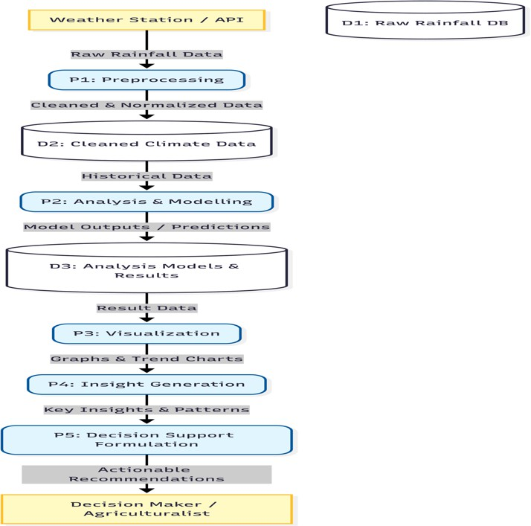

Technology Stack
    - Python
    - Pandas / NumPy
    - Matplotlib / Seaborn
    - Scikit-learn
    - Jupyter Notebook

PROJECT DESIGN

Problem Solution Fit
The solution aligns analytical capabilities with agricultural needs by transforming rainfall data into actionable insights, enabling improved planning and risk mitigation.

Proposed Solution
Develop an analytical pipeline that processes rainfall datasets, identifies patterns, generates visualizations, and applies predictive modelling to support decision-making.

Solution Architecture
Data Input → Processing Module → Analysis Engine → Visualization Layer → Output Insights

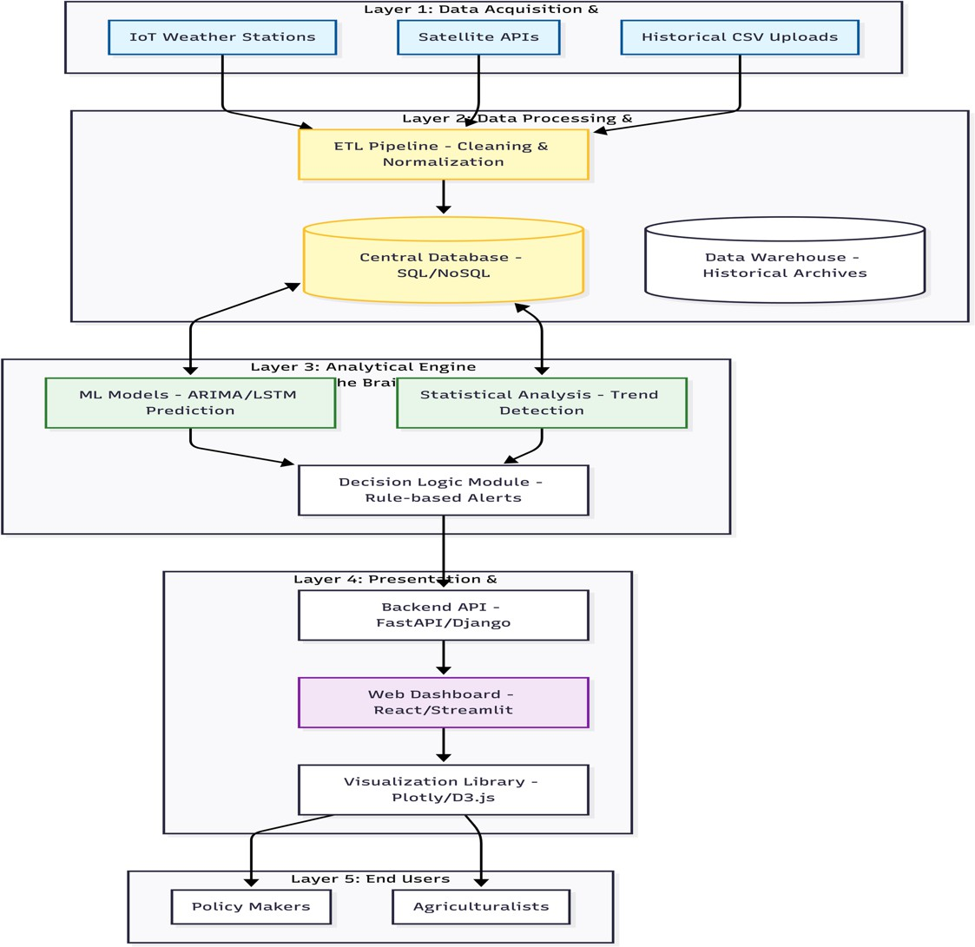

PROJECT PLANNING & SCHEDULING

Project Planning
    - Data collection
    - Data preprocessing
    - Exploratory analysis
    - Model development
    - Visualization creation
    - Documentation & testing

FUNCTIONAL AND PERFORMANCE TESTING

Performance Testing
The system was evaluated based on data processing accuracy, visualization clarity, and model responsiveness to ensure reliable outputs and efficient execution.

RESULTS

Index.html:
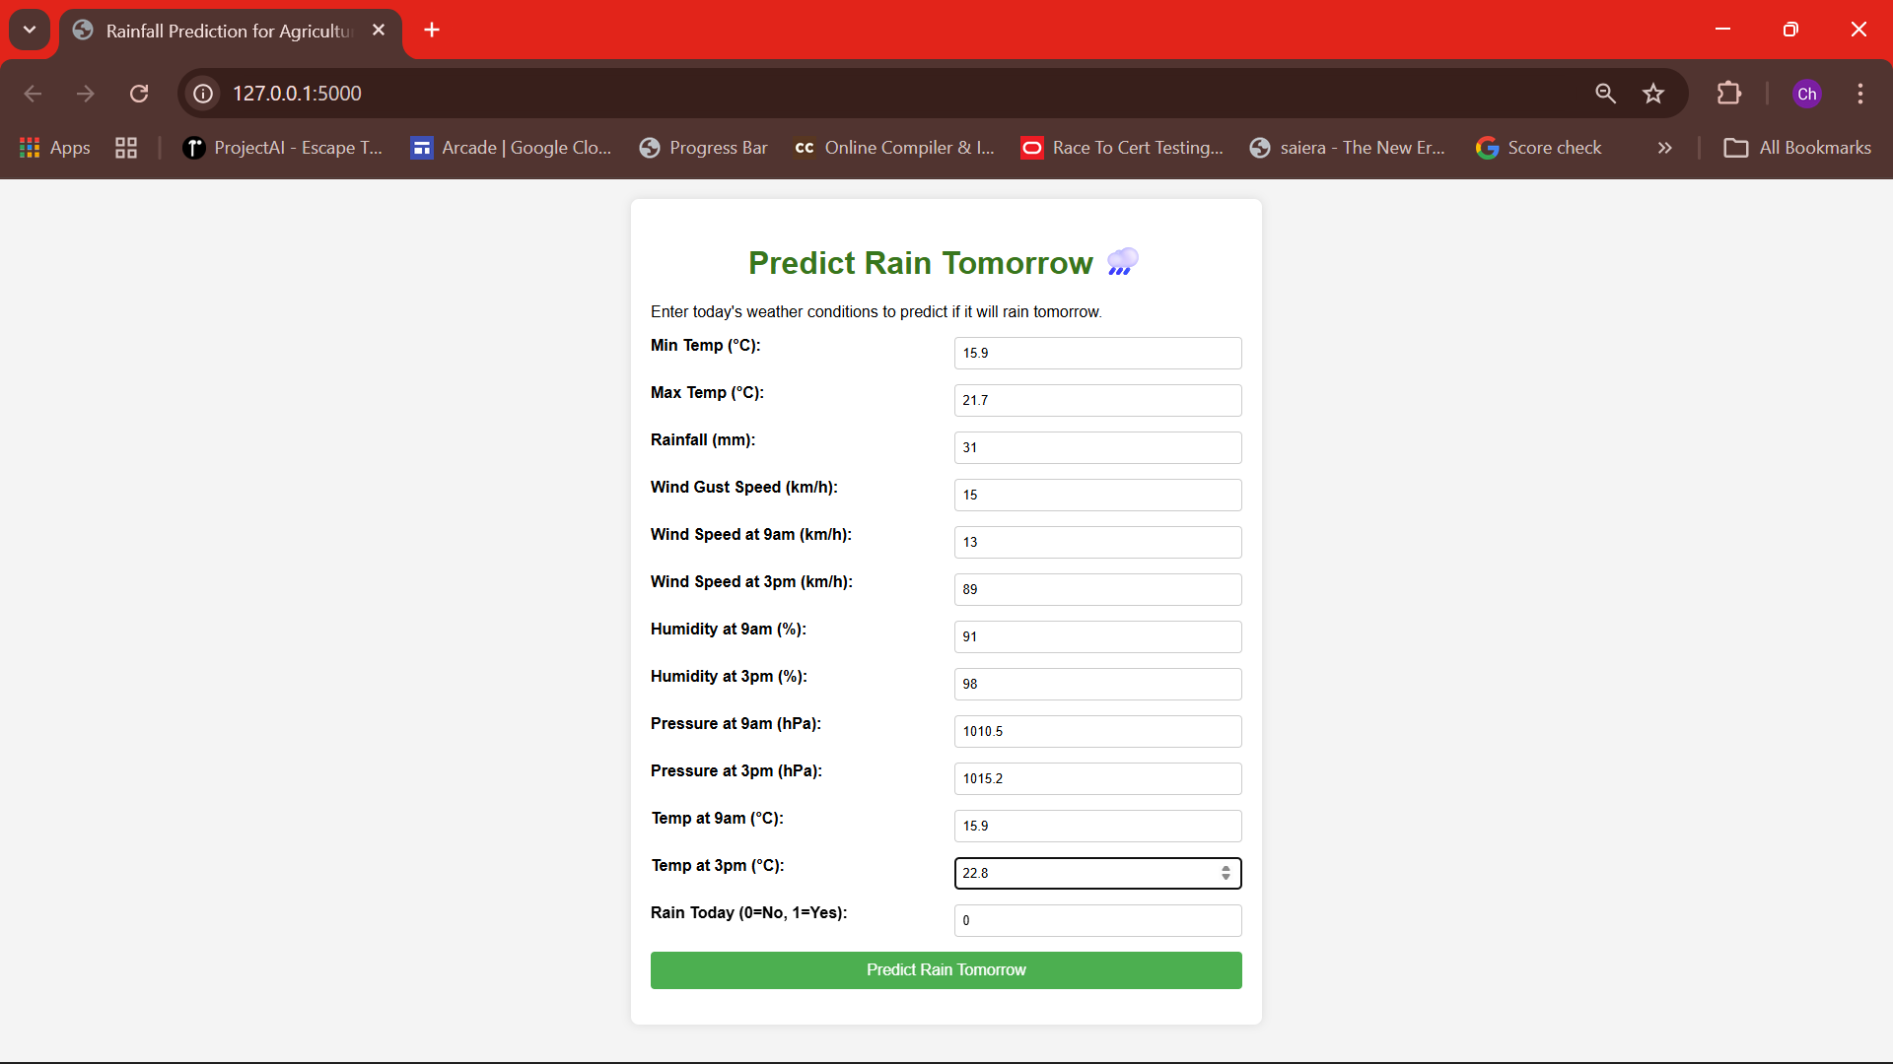

  - chance.html:
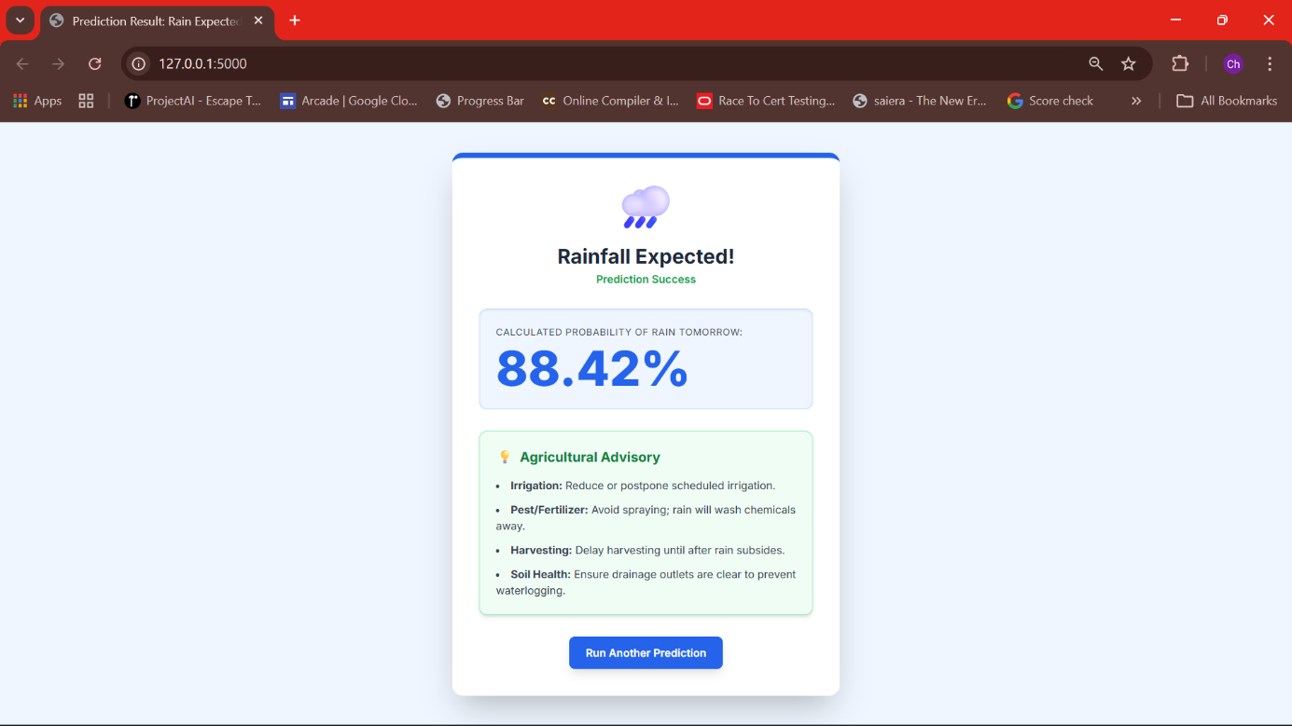

  - noChance.html:
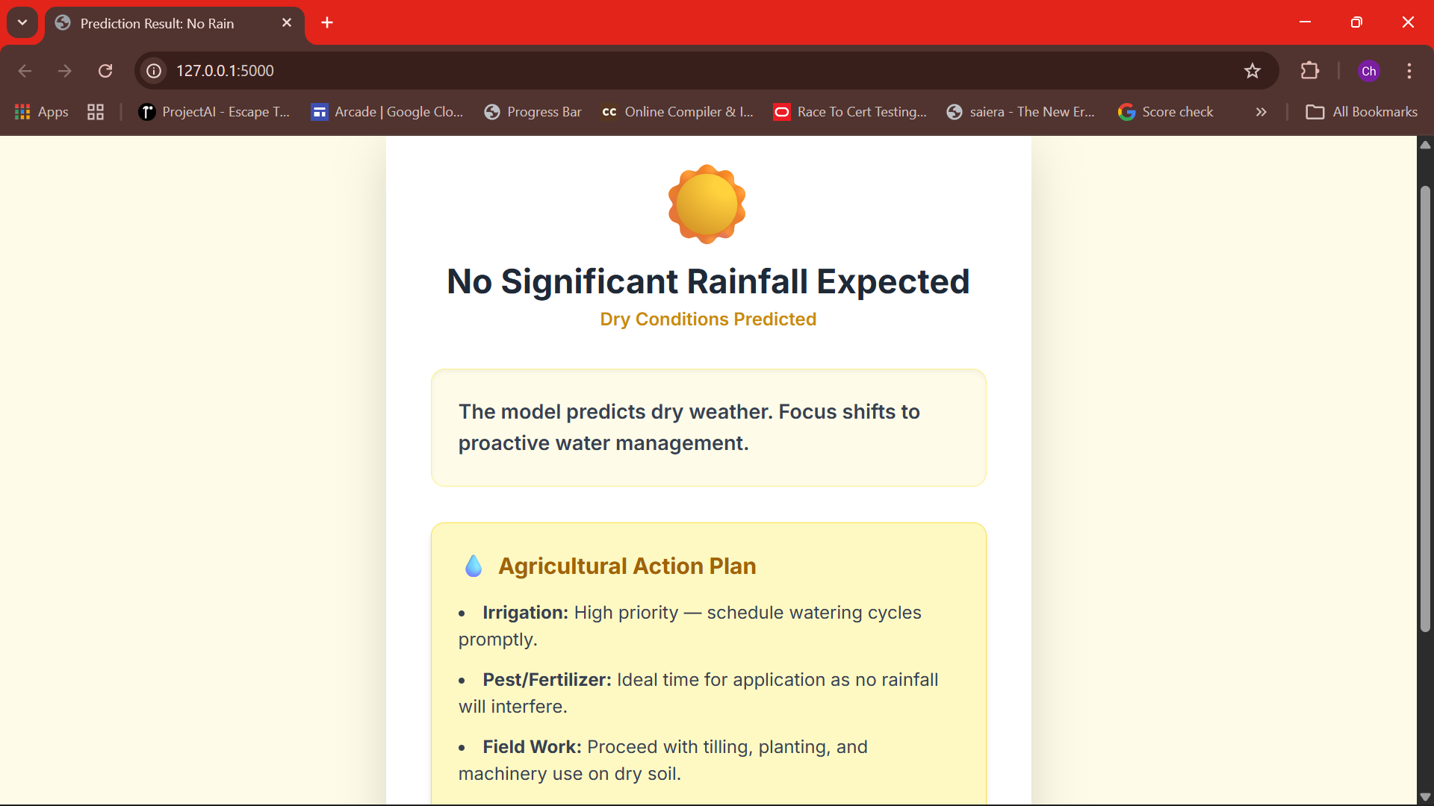

  - app.py:
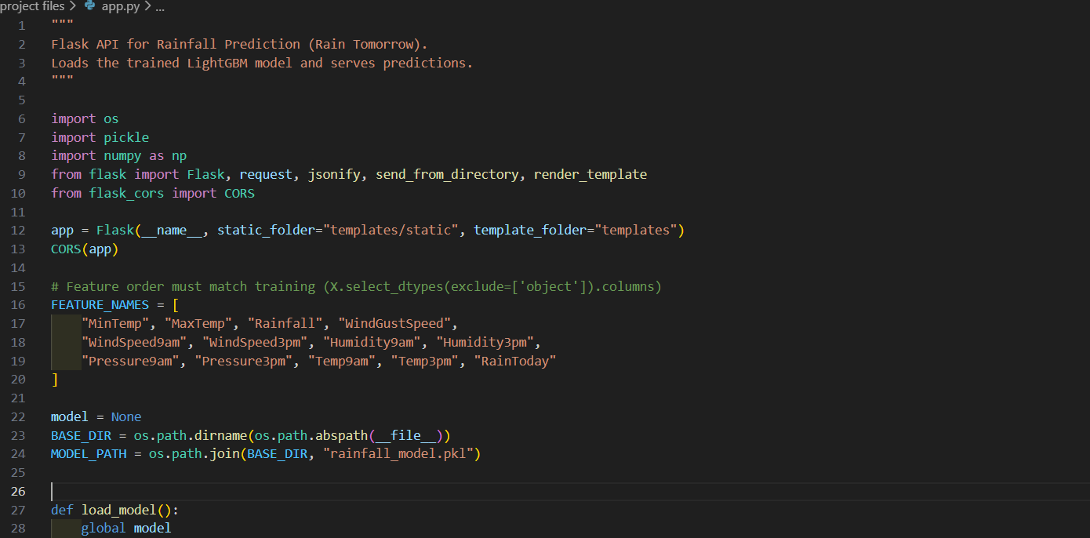

ADVANTAGES & DISADVANTAGES

Advantages
- Supports data-driven agricultural planning
- Identifies rainfall trends
- Helps manage irrigation resources
- Provides risk assessment insights

Disadvantages
- Depends on data quality
- Limited predictive accuracy
- Requires technical tools for interpretation

CONCLUSION
The project demonstrates how exploratory data analysis can convert rainfall datasets into meaningful insights that aid agricultural decision-making. By leveraging analytical and visualization techniques, it highlights trends and supports informed planning strategies.

FUTURE SCOPE
- Integrating real-time weather data
- Advanced predictive modelling
- Mobile dashboard deployment
- Integration with crop recommendation systems

GitHub & Project Demo Link

